CREATE TABLE ITEMS_EXP9_CSA_46 (ITEMID INT PRIMARY KEY, ITEMNAME VARCHAR(50),CATEGORYS VARCHAR(50),PRICE INT, INSTOCK INT CHECK (INSTOCK >= 0));

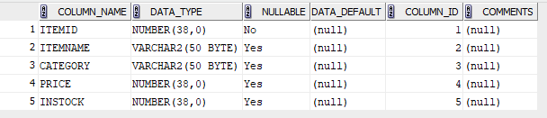

CREATE TABLE CUSTOMERS_EXP9_CSA_46 (CUSTID INT PRIMARY KEY, CUSTNAME VARCHAR(100), ADDRESS VARCHAR(255), STATE VARCHAR(50));

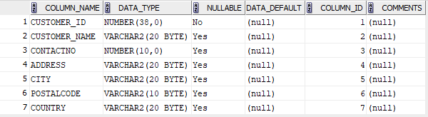

CREATE TABLE ORDERS_EXP9_CSA_46 ( ORDERID INT PRIMARY KEY, ITEMID INT, CUSTID INT, QUANTITY INT, ORDERDATE DATE, FOREIGN KEY (ITEMID) REFERENCES ITEMS_EXP9_CSA_46, FOREIGN KEY (CUSTID) REFERENCES CUSTOMERS_EXP9_CSA_46);

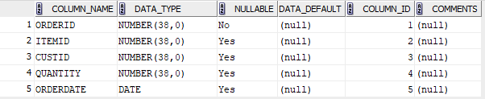

CREATE TABLE DELIVERY_EXP9_CSA_46 (DELIVERYID INT PRIMARY KEY, CUSTID INT, ORDERID INT,FOREIGN KEY (CUSTID) REFERENCES CUSTOMERS_EXP9_CSA_46, FOREIGN KEY (ORDERID) REFERENCES ORDERS_EXP9_CSA_46);

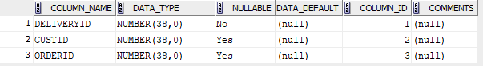

INSERT INTO ITEMS_EXP9_CSA_46 VALUES(1,'SAMSUNG GALAXY S4','MOBILE',45000,1000);

INSERT INTO ITEMS_EXP9_CSA_46 VALUES(2,'CASIO','WATCH',7000,5000);

INSERT INTO ITEMS_EXP9_CSA_46 VALUES(3,'SONY BRAVIA','TV',250000,200);

INSERT INTO ITEMS_EXP9_CSA_46 VALUES(4,'PUMA','BAG',2000,8000);

INSERT INTO ITEMS_EXP9_CSA_46 VALUES(5,'ADIDAS','SHOES',8000,6000);

SELECT * FROM ITEMS_EXP9_CSA_46;

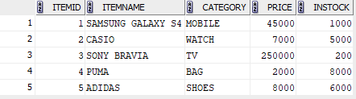

INSERT INTO CUSTOMERS_EXP9_CSA_46 VALUES (1, 'Alice Johnson', '123 Maple St', 'CA');

INSERT INTO CUSTOMERS_EXP9_CSA_46 VALUES (2, 'Mickey', '456 Oak Ave', 'NY');

INSERT INTO CUSTOMERS_EXP9_CSA_46 VALUES (3, 'Charlie Brown', '789 Pine Rd', 'NY');

INSERT INTO CUSTOMERS_EXP9_CSA_46 VALUES (4, 'Diana Prince', '321 Elm St', 'FL');

INSERT INTO CUSTOMERS_EXP9_CSA_46 VALUES (5, 'Jaswin James', '654 Birch Blvd', 'WA');

SELECT * FROM CUSTOMERS_EXP9_CSA_46;

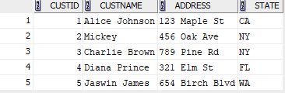

INSERT INTO ORDERS_EXP9_CSA_46 VALUES (1, 1, 1, 1, '02-MAR-2018');

INSERT INTO ORDERS_EXP9_CSA_46 VALUES (2, 2, 2, 2, '02-JAN-2013');

INSERT INTO ORDERS_EXP9_CSA_46 VALUES (3, 3, 3, 1, '03-FEB-2013');

INSERT INTO ORDERS_EXP9_CSA_46 VALUES (4, 4, 4, 3, '04-DEC-2016');

INSERT INTO ORDERS_EXP9_CSA_46 VALUES (5, 2, 1, 5, '05-AUG-2012');

SELECT * FROM ORDERS_EXP9_CSA_46;

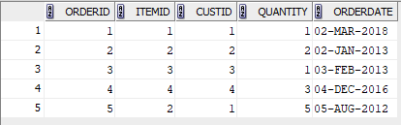

INSERT INTO DELIVERY_EXP9_CSA_46 VALUES (1, 1, 1);

INSERT INTO DELIVERY_EXP9_CSA_46 VALUES (2, 2, 2);

INSERT INTO DELIVERY_EXP9_CSA_46 VALUES (3, 4, 4);

SELECT * FROM DELIVERY_EXP9_CSA_46;

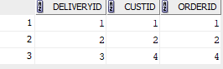

**QUESTIONS**

1. SELECT * FROM CUSTOMERS_EXP9_CSA_46 C JOIN ORDERS_EXP9_CSA_46 O ON C.CUSTID = O.CUSTID;

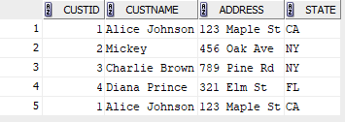

1. SELECT C.CUSTID,CUSTNAME,ADDRESS,STATE FROM CUSTOMERS_EXP9_CSA_46 C JOIN DELIVERY_EXP9_CSA_46 D ON D.CUSTID = C.CUSTID;

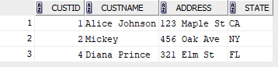

1. SELECT C.CUSTNAME,O.ORDERDATE FROM CUSTOMERS_EXP9_CSA_46 C JOIN ORDERS_EXP9_CSA_46 O ON C.CUSTID=O.CUSTID WHERE C.CUSTNAME LIKE 'J%';

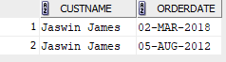

1. SELECT ITEMNAME,PRICE FROM ITEMS_EXP9_CSA_46 I JOIN ORDERS_EXP9_CSA_46 O ON I.ITEMID = O.ITEMID JOIN CUSTOMERS_EXP9_CSA_46 C ON C.CUSTID = O.CUSTID WHERE CUSTNAME = 'Mickey';



1. SELECT DISTINCT ITEMID FROM ORDERS_EXP9_CSA_46 UNION SELECT DISTINCT I.ITEMID FROM ITEMS_EXP9_CSA_46 I LEFT JOIN DELIVERY_EXP9_CSA_46 D ON I.ITEMID = D.ORDERID WHERE D.DELIVERYID IS NULL;

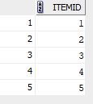

1. SELECT DISTINCT c.Custname FROM CUSTOMERS_EXP9_CSA_46 c JOIN ORDERS_EXP9_CSA_46 o ON c.custid = o.Custid JOIN DELIVERY_EXP9_CSA_46 D ON O.ORDERID = D.ORDERID;

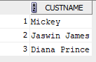

1. SELECT DISTINCT C.CUSTNAME FROM CUSTOMERS_EXP9_CSA_46 C JOIN ORDERS_EXP9_CSA_46 O ON C.CUSTID = O.CUSTID LEFT JOIN DELIVERY_EXP9_CSA_46 D ON O.ORDERID = D.ORDERID WHERE D.DELIVERYID IS NULL MINUS SELECT DISTINCT C.CUSTNAME FROM CUSTOMERS_EXP9_CSA_46 C JOIN ORDERS_EXP9_CSA_46 O ON C.CUSTID = O.CUSTID JOIN DELIVERY_EXP9_CSA_46 D ON O.ORDERID = D.ORDERID;

